|  |
| --- |
| GATE |
| Linear Algebra |
| PYS’s and Solution |

|  |
| --- |
| VARUN KUMAR  7-31-2025 |

Table of Contents

**CSE** 3

2025 3

2024 4

2023 6

2022 7

2021, S-1 9

2021, S-2 10

2020 10

2019 10

2018 11

**ECE** 12

2025 12

2024 12

2023 13

2022 14

2021 15

2020 15

2019 16

2018 16

**EEE** 17

2025 17

2024 18

2023 19

2022 19

2021 20

2020 21

2019 21

2018 22

**Civil** 23

2025 23

2024 25

2023 26

2022 28

2021 29

2020 31

2019 32

2018 32

**Mechanical** 34

2025 34

**Instrumentation Engineering** 35

2025 35

**Data Science and Artificial Intelligence** 36

2025 36

# **CSE**

## 2025

**S1**

**Q.** Consider the given system of linear equations for variables 𝑥 and 𝑦, where 𝑘 is a real-valued constant. Which of the following option(s) is/are CORRECT?

$$x + ky = 1$$

$$kx + y = -1$$

1. There is exactly one value of 𝑘 for which the above system of equations has no solution.
2. There exist an infinite number of values of 𝑘 for which the system of equations has no solution.
3. There exists exactly one value of 𝑘 for which the system of equations has exactly one solution.
4. There exists exactly one value of 𝑘 for which the system of equations has an infinite number of solutions.

ANS: - a, d

**Q.** Let 𝐴 be a 2 × 2 matrix as given.

$$A= \left(\begin{matrix}1 & 1 \\ 1 & -1\end{matrix}\right)$$

What are the eigenvalues of the matrix 𝐴13?

1. 1, −1
2. 2√2, −2√2
3. 4√2, −4√2
4. 64√2, −64√2

**ANS: - d**

**S2**

**Q**. If $A= \left(\begin{matrix}1 & 2 \\ 2 & -1\end{matrix}\right)$ then which ONE of the following is 𝐴8?

a. c.

b. d.

ANS: - c

**Q.** Let 𝐿, 𝑀, and 𝑁 be non-singular matrices of order 3 satisfying the equations

$$L^{2}= L^{-1}, M=L^{8}, and N= L^{2}$$

Which ONE of the following is the value of the determinant of (𝑀 − 𝑁)?

1. 0
2. 1
3. 2
4. 3

ANS: - a

**Q.** Consider a system of linear equations 𝑃𝑋 = 𝑄 where $P ∈ R^{3 X 3}$ and $Q ∈ R^{3 X 1}$. Suppose 𝑃 has an LU decomposition, 𝑃 = 𝐿𝑈, where

L = $\left[\begin{matrix}1 & 0 & 0 \\ l_{21} & 1 & 0 \\ l_{31} & l_{32} & 1\end{matrix}\right]$ and $U=\left[\begin{matrix}u_{11} & u_{12} & u_{13} \\ 0 & u_{22} & u_{23} \\ 0 & 0 & u_{33}\end{matrix}\right]$

Which of the following statement(s) is/are TRUE?

1. The system 𝑃𝑋 = 𝑄 can be solved by first solving 𝐿𝑌 = 𝑄 and then 𝑈𝑋 = 𝑌.
2. If 𝑃 is invertible, then both 𝐿 and 𝑈 are invertible
3. If 𝑃 is singular, then at least one of the diagonal elements of 𝑈 is zero.
4. If 𝑃 is symmetric, then both 𝐿 and 𝑈 are symmetric.

ANS: - a, b, c

## 2024

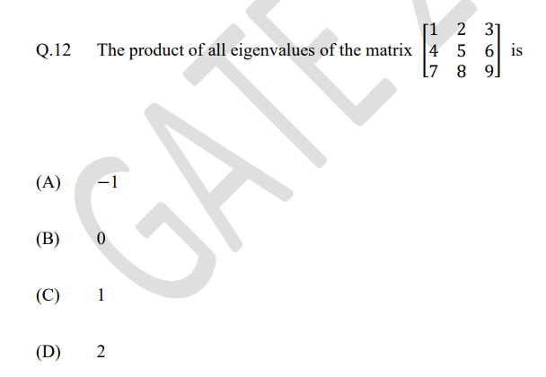

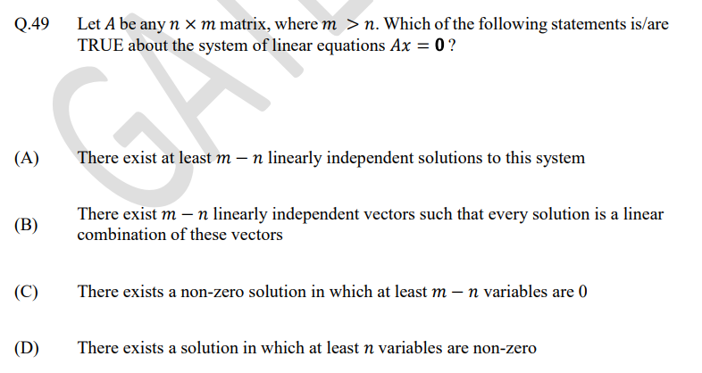

**S2**

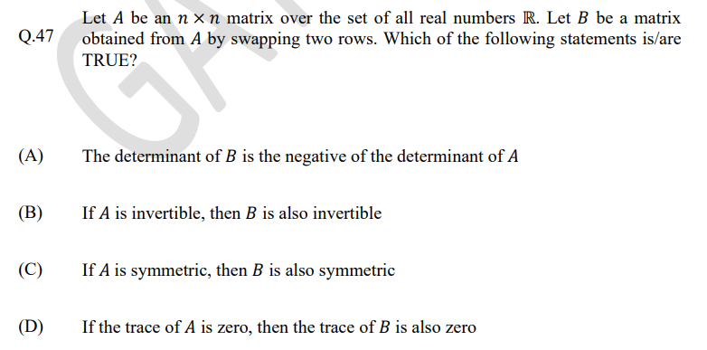

## 2023

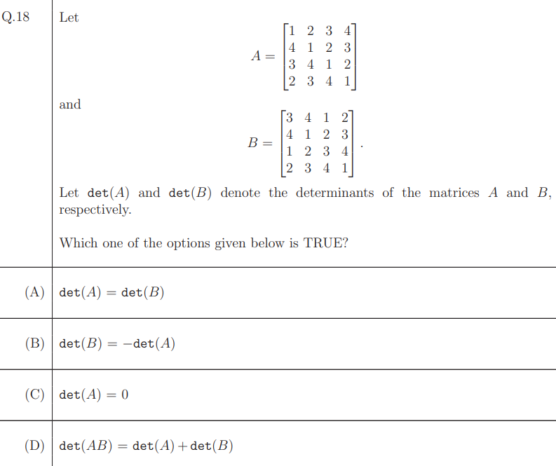

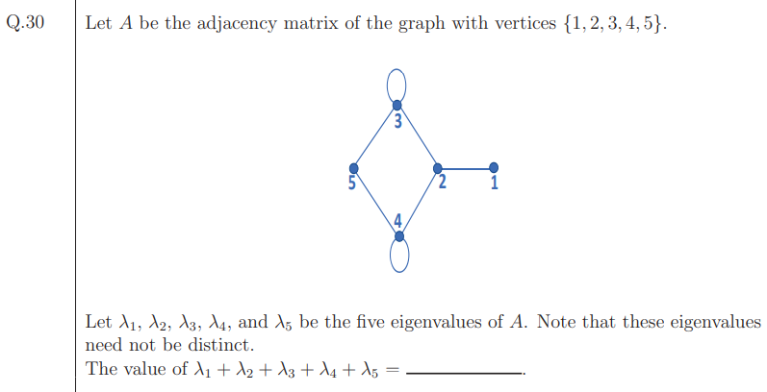

## 2022

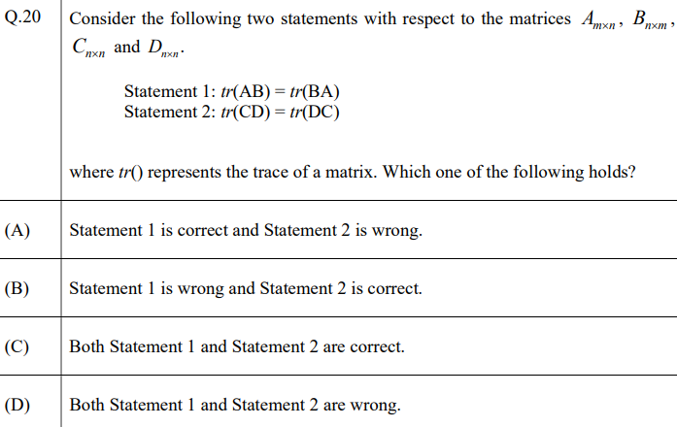

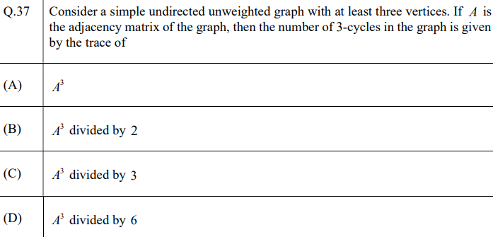

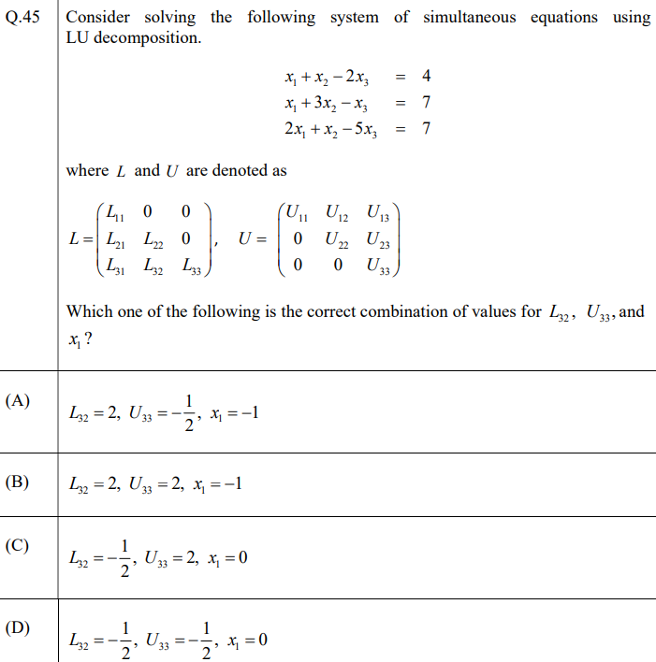

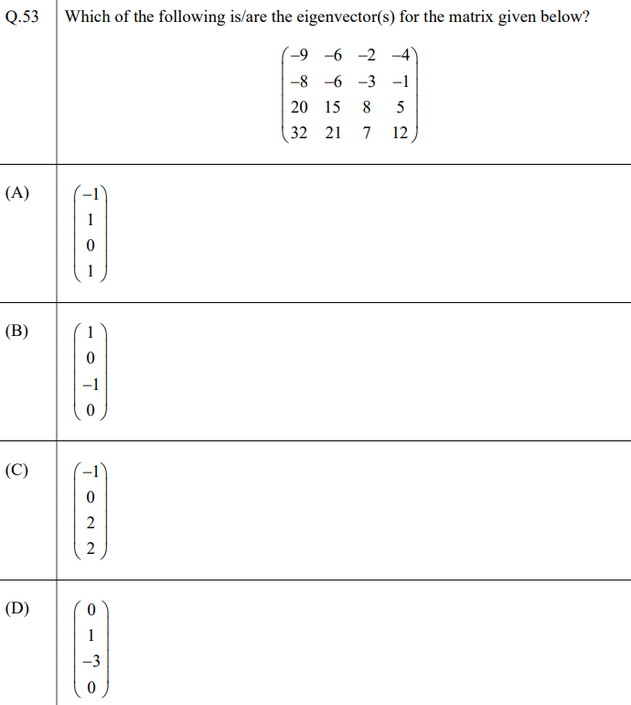

## 2021, S-1

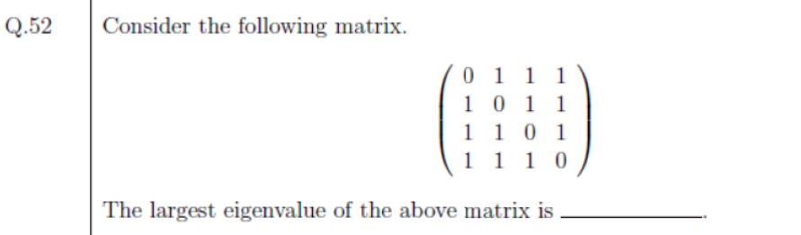

ANS: - 3

## 2021, S-2

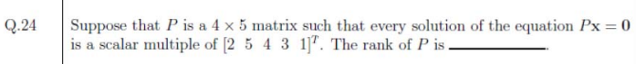

ANS: - 4

## 2020

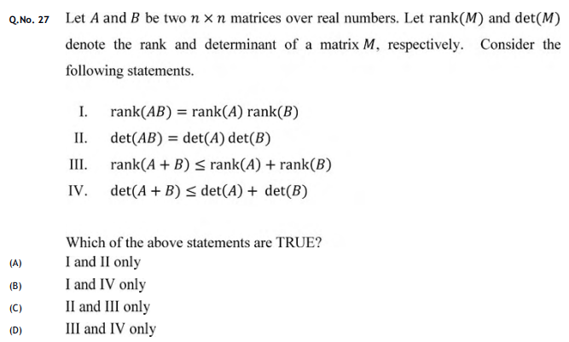

ANS: - C

## 2019

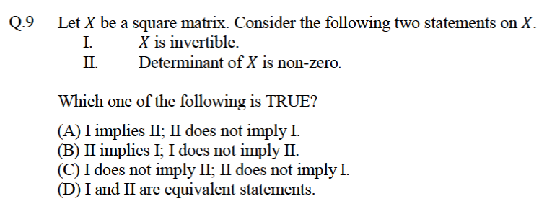

ANS: - D

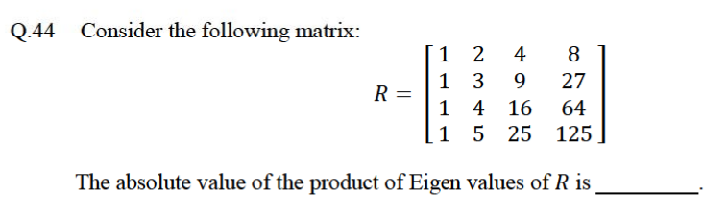

ANS: - 12

## 2018

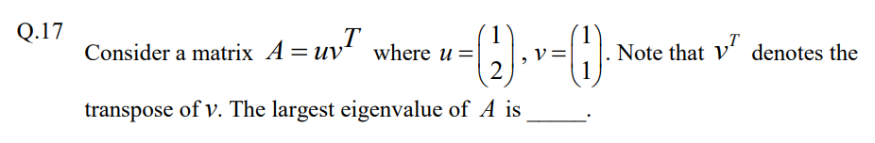

ANS: - 3

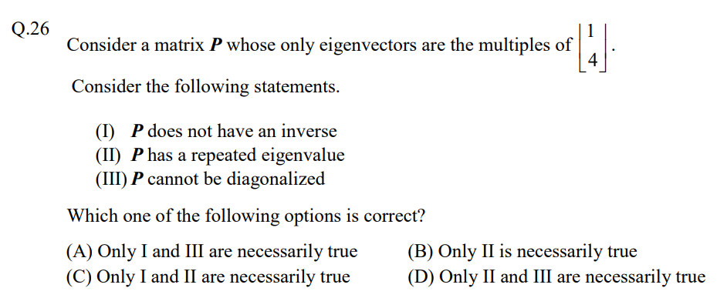

ANS: - D

# **ECE**

## 2025

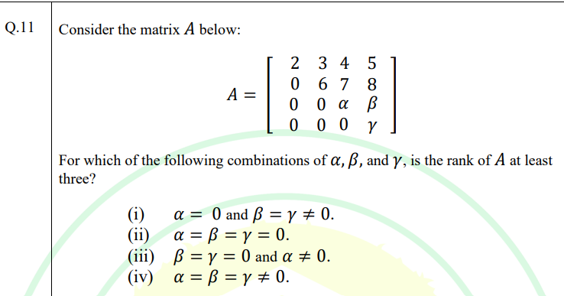

(A) Only (i), (iii), and (iv)

(B) Only (iv)

(C) Only (ii)

(D) Only (i) and (iii)

ANS: - A

## 2024

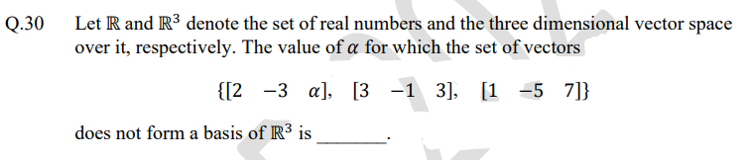

ANS: - 5 (Check the answer)

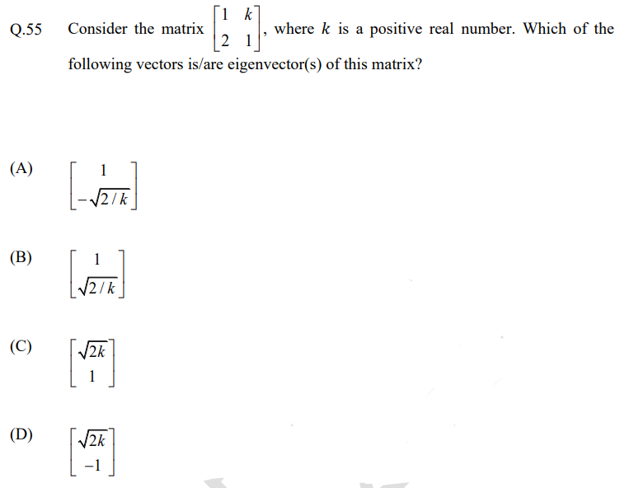

ANS: - A, B (check the answer)

## 2023

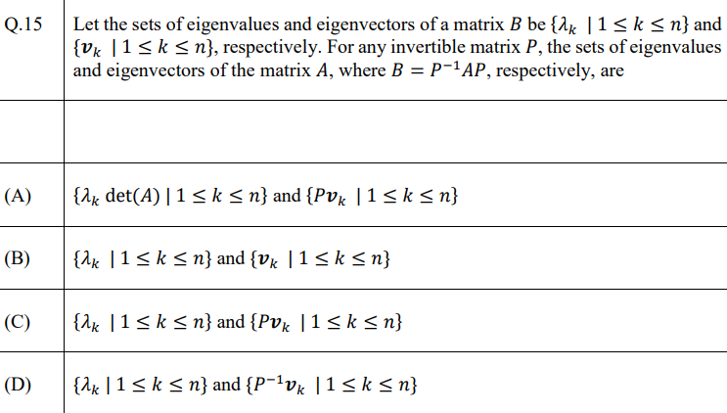

ANS: -

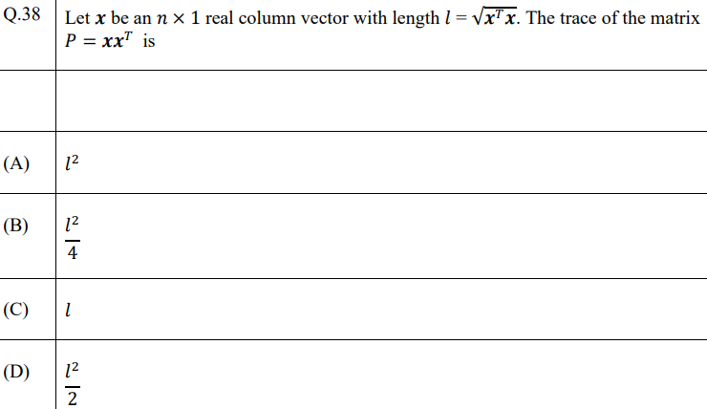

ANS: -

## 2022

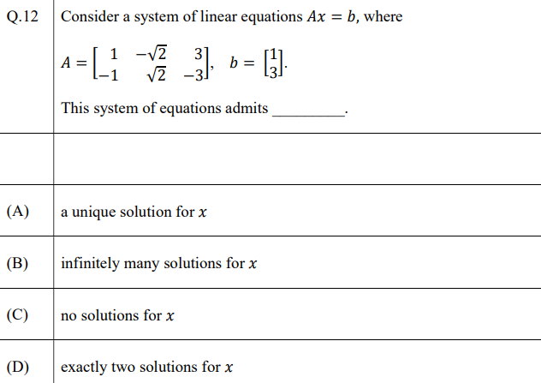

ANS: -

## 2021



ANS: -

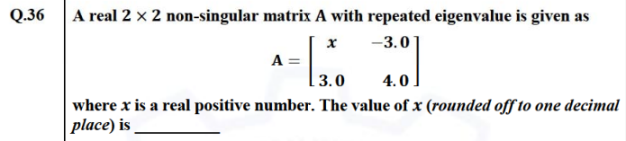

ANS: -

## 2020

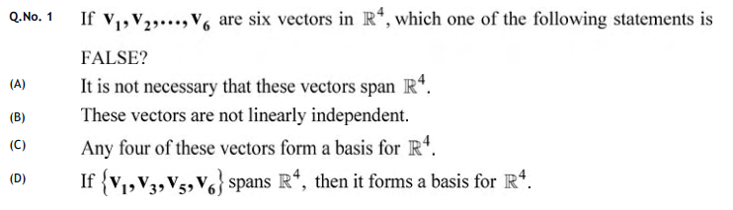

ANS: - C

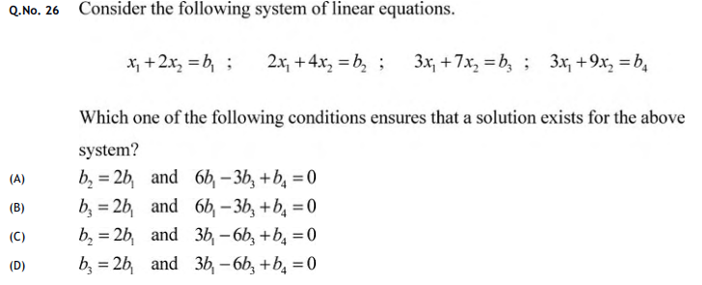

ANS: - A

## 2019

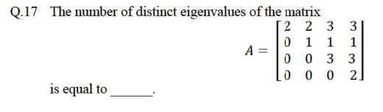

ANS: - 3

## 2018

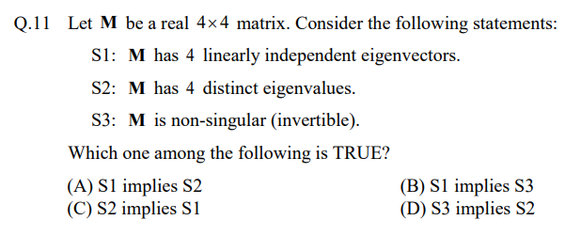

ANS: - C

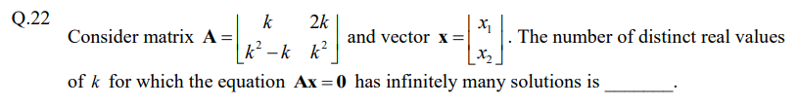

ANS: - 2

# **EEE**

## 2025

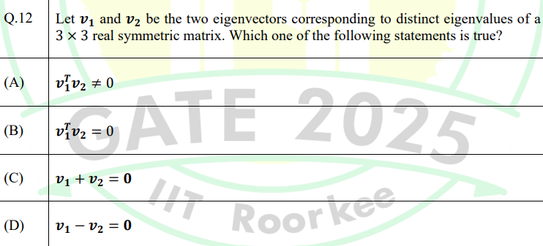

ANS: - B

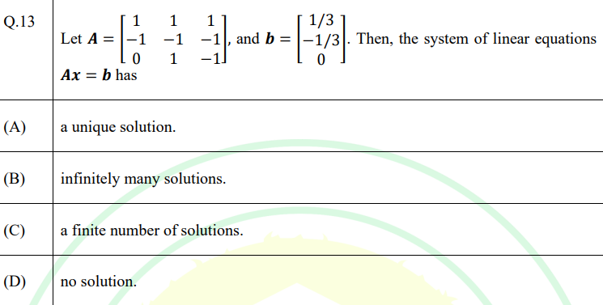

ANS: - B

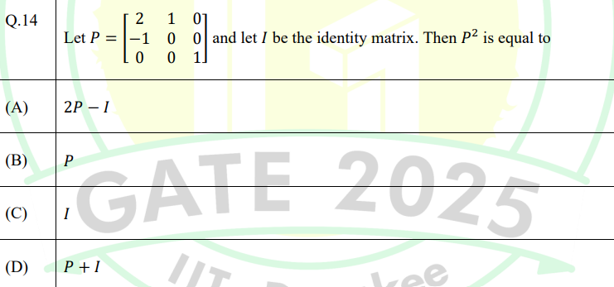

ANS: - A

## 2024

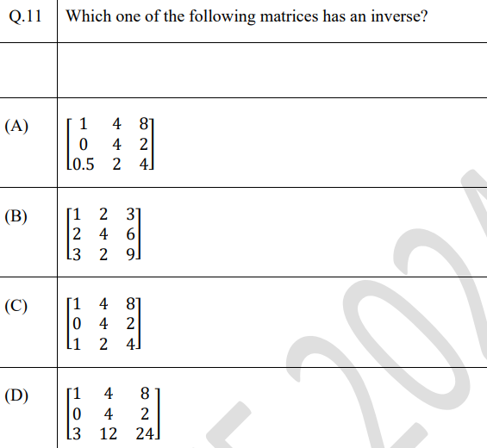

ANS: -

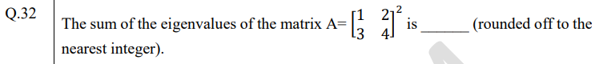

ANS: -

## 2023

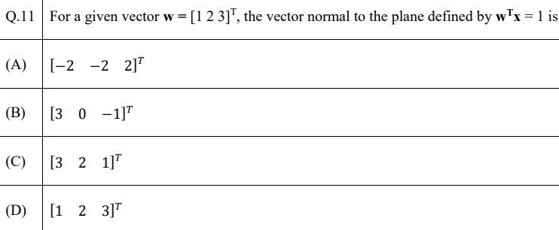

ANS: -

## 2022

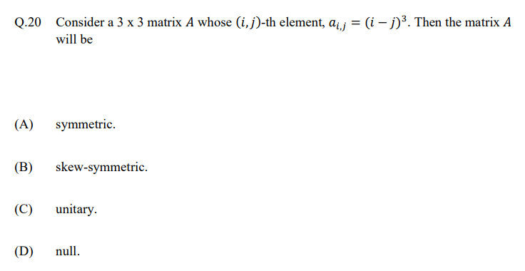

ANS: -

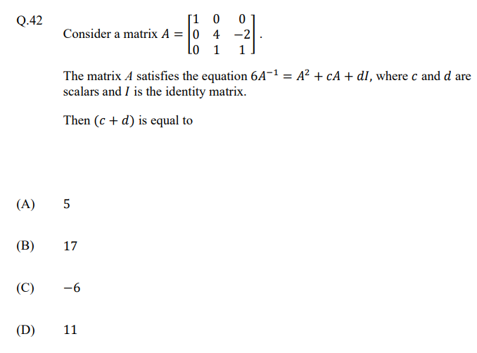

ANS: -

## 2021

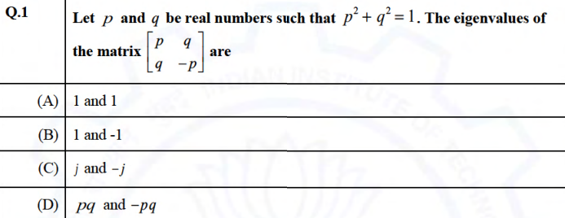

ANS: - B

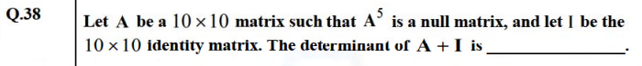

ANS: - 1

## 2020

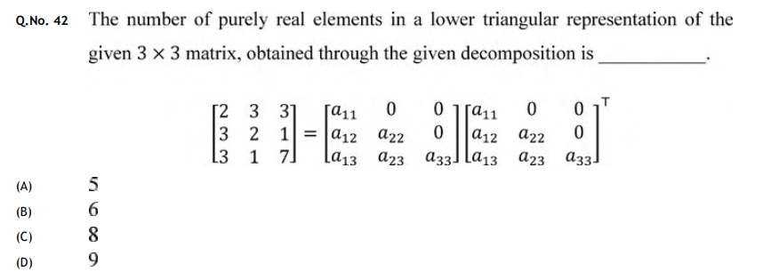

ANS: - MTA

## 2019

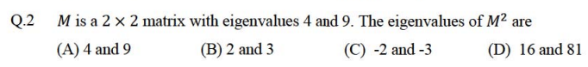

ANS: - D

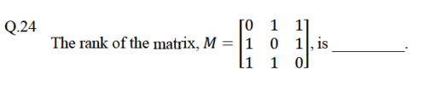

ANS: - 3

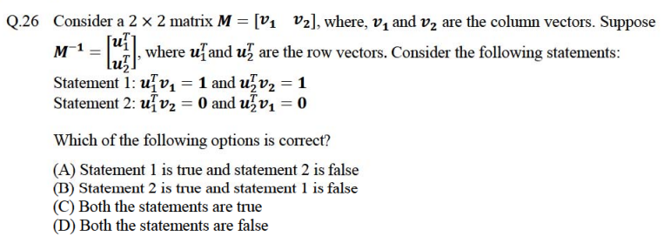

ANS: - C

## 2018

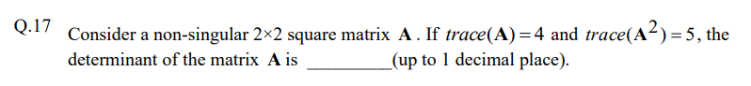

ANS: - 5.5

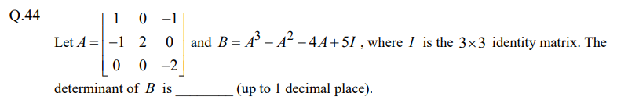

ANS: - 0.9 - 1.1

# **Civil**

## 2025

CE 1

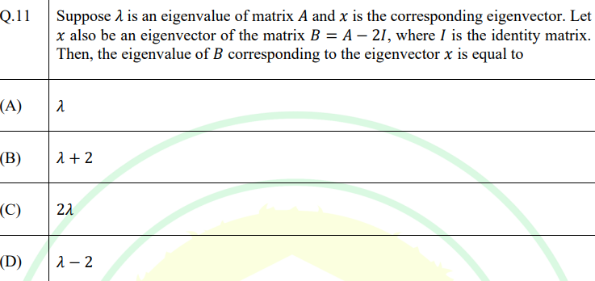

ANS: - D

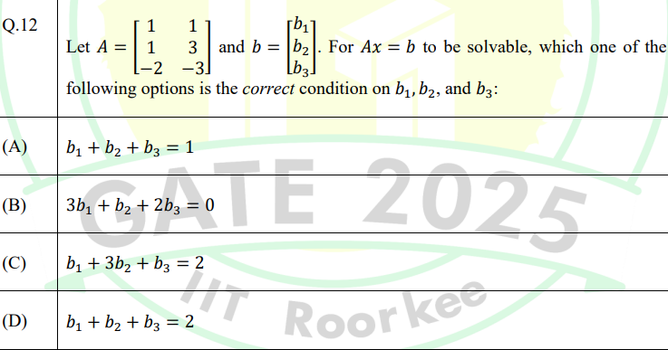

ANS: - B

CE – 2

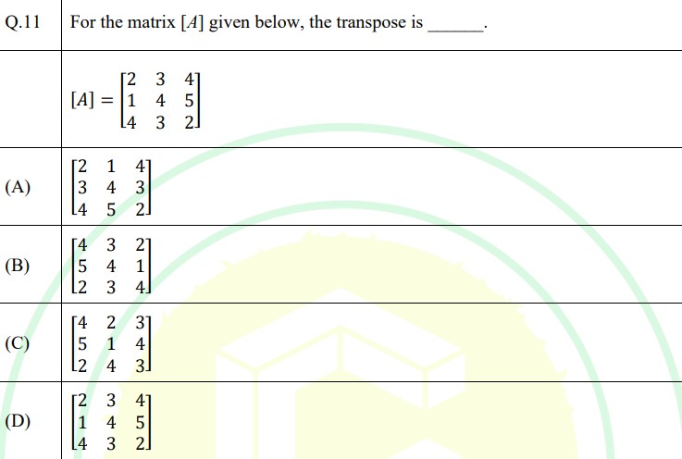

ANS: - A

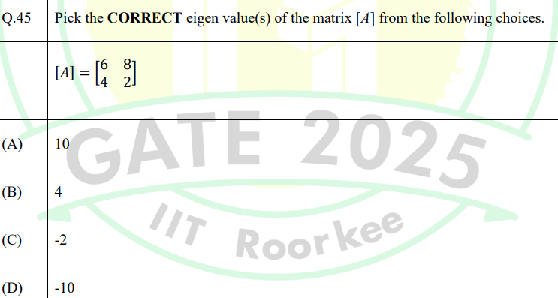

ANS: - A, C

## 2024

**S1**

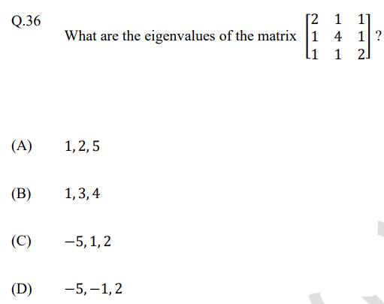

ANS: -

**S2**

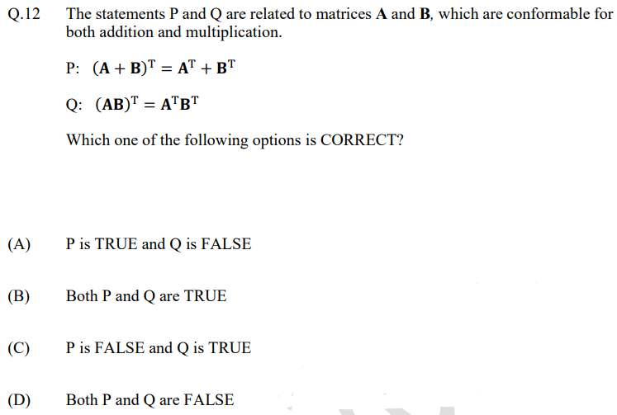

ANS: -

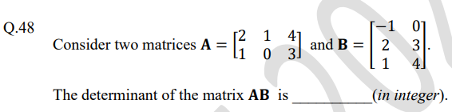

ANS: -

## 2023

**S1**

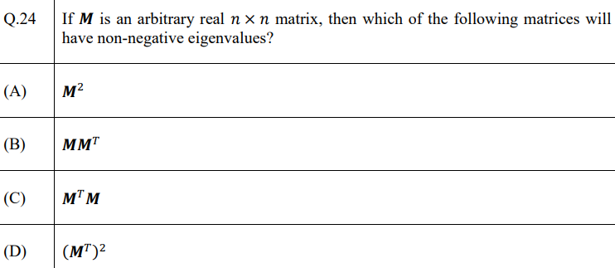

ANS: - B, C

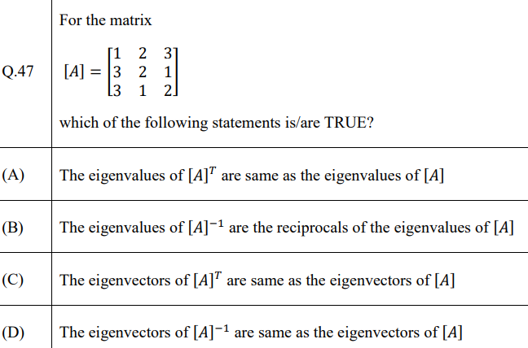

ANS: - A, B, D

**S2**

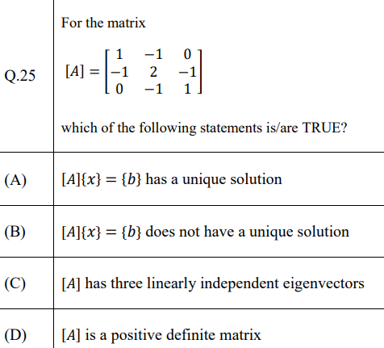

ANS: - B,C

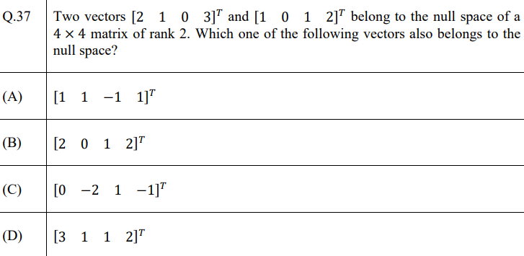

ANS: - A

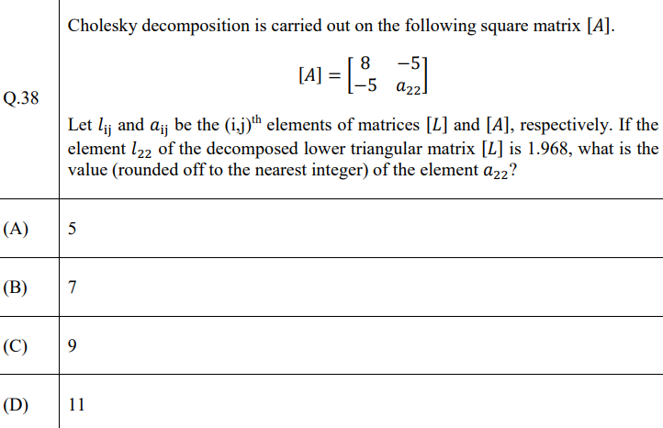

ANS: - B

## 2022

S1

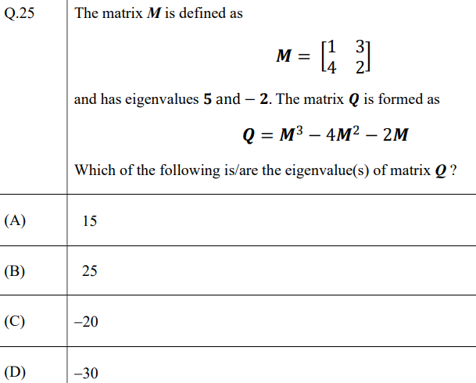

ANS: - A, C

S2

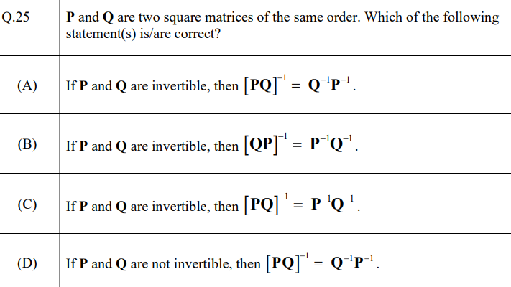

ANS: - A, B

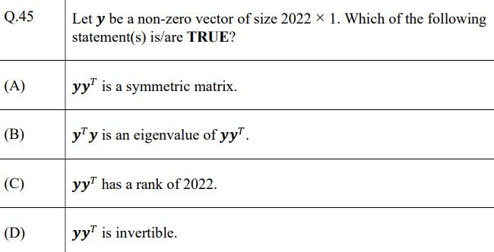

ANS: - A, B

## 2021

S1

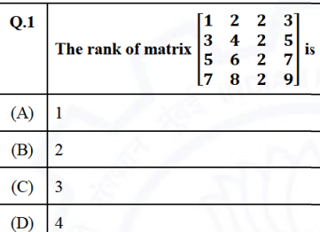

ANS: - B

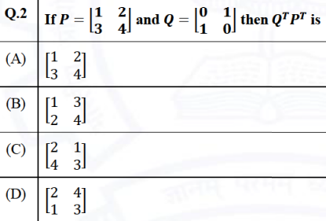

ANS: - D

S2

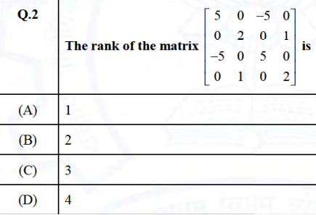

ANS: - C

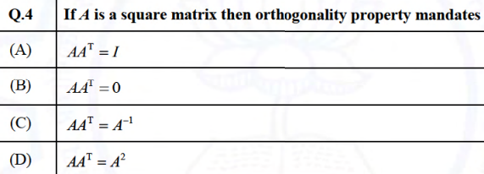

ANS: - A

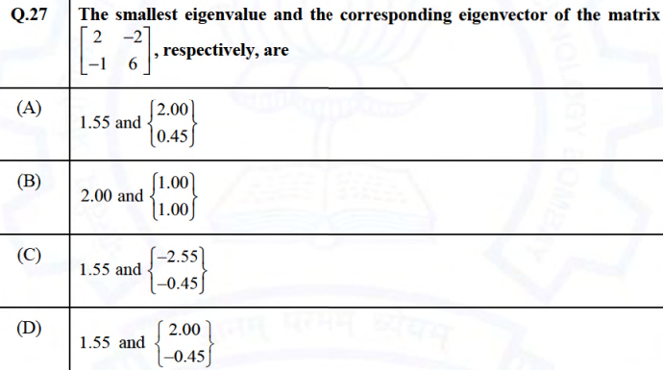

ANS: - A

## 2020

S1

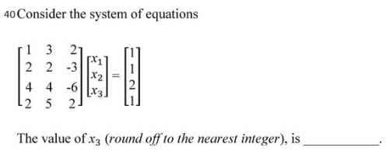

ANS: - 3

S2

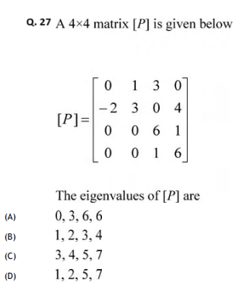

ANS: -

## 2019

S2

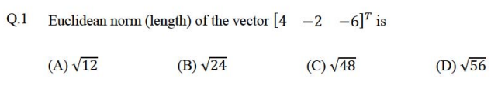

ANS: - D

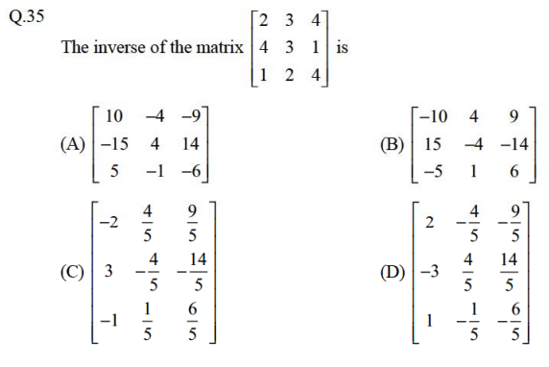

ANS: - C

## 2018

S1

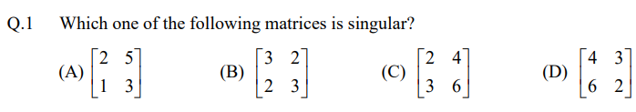

ANS: - C

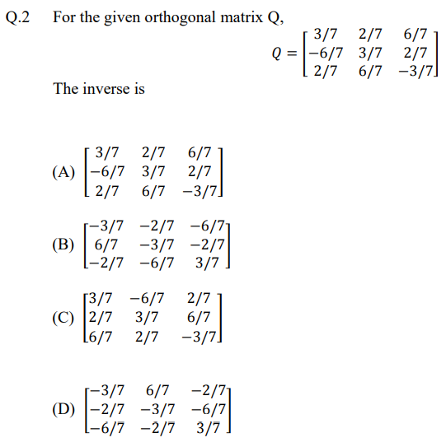

ANS: - C

S2

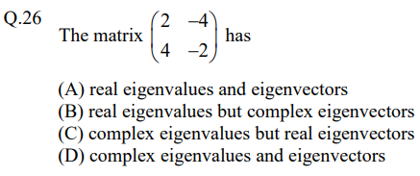

ANS: - D

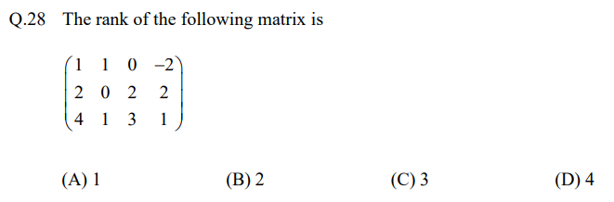

ANS: - B

# **Mechanical**

## 2025

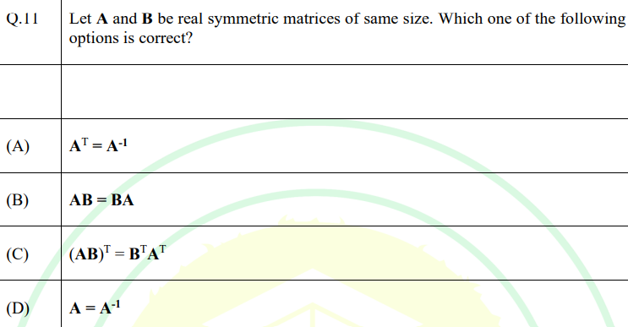

ANS: - C

# **Instrumentation Engineering**

## 2025

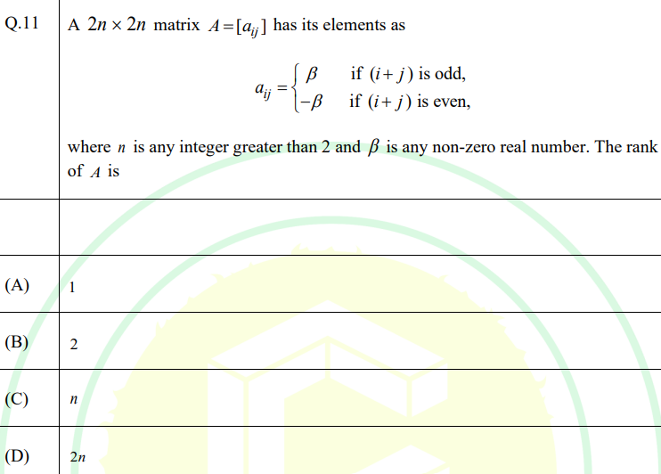

ANS: - A

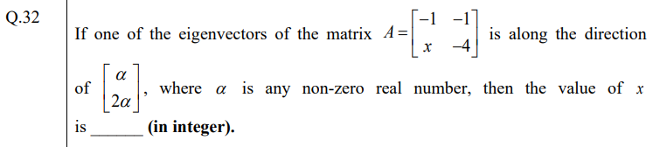

ANS: - 2

# **Data Science and Artificial Intelligence**

## 2025

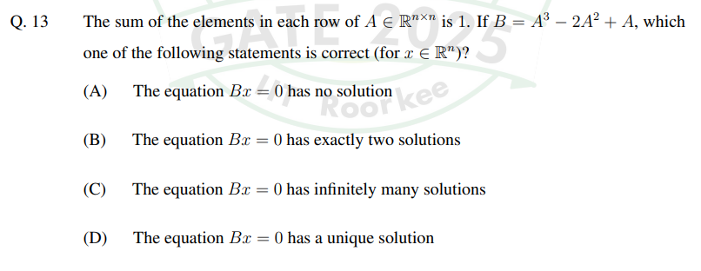

ANS: - C

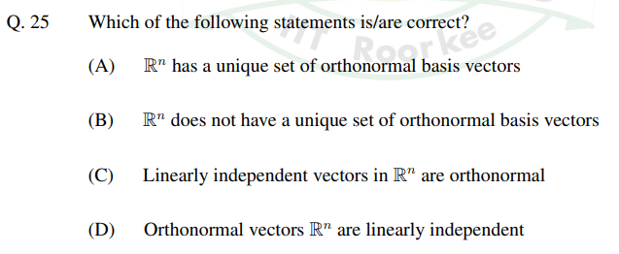

ANS: - B, D

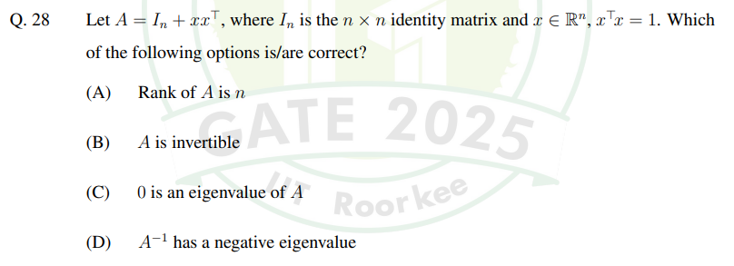

ANS: - A, B

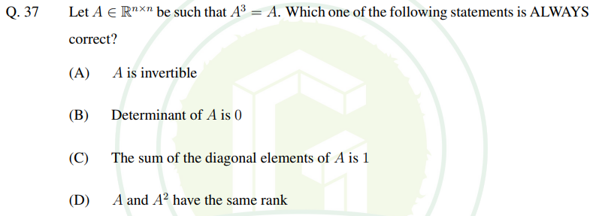

ANS: - D

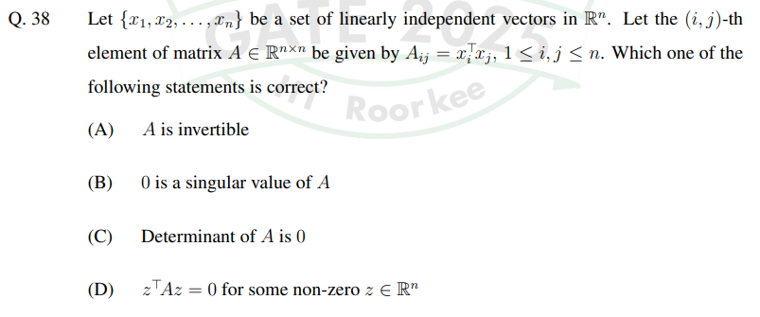

ANS: - A

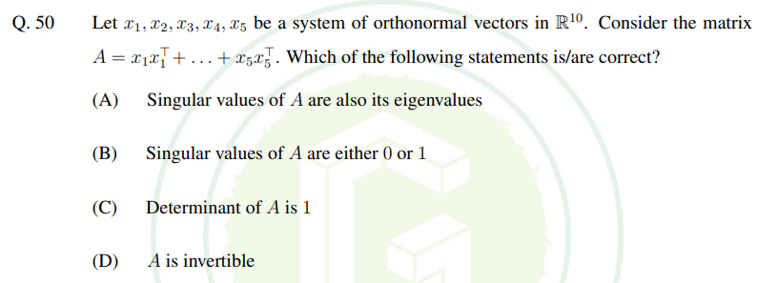

ANS: - A, B

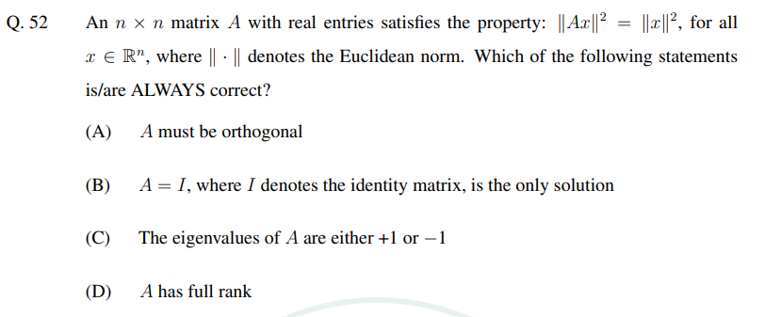

ANS: - A, D